## Week 1 - Neural Networks for Sentiment Analysis

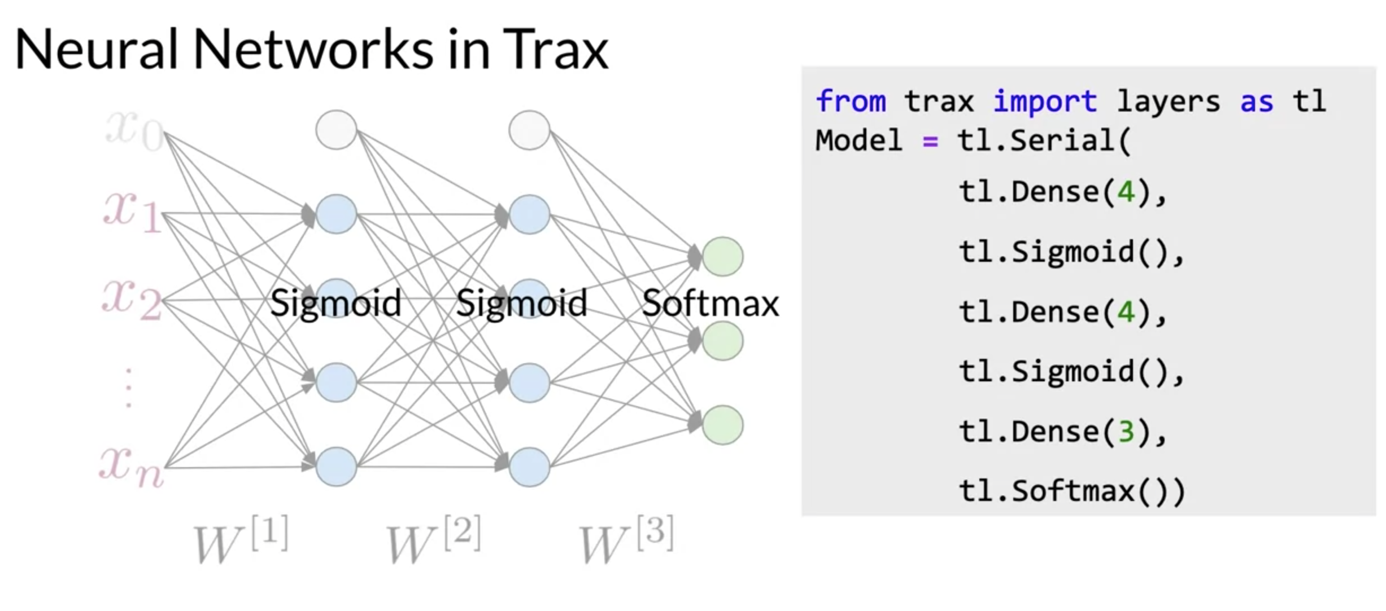

## Week 2 - Recurrent Neural Networks for Language Modeling

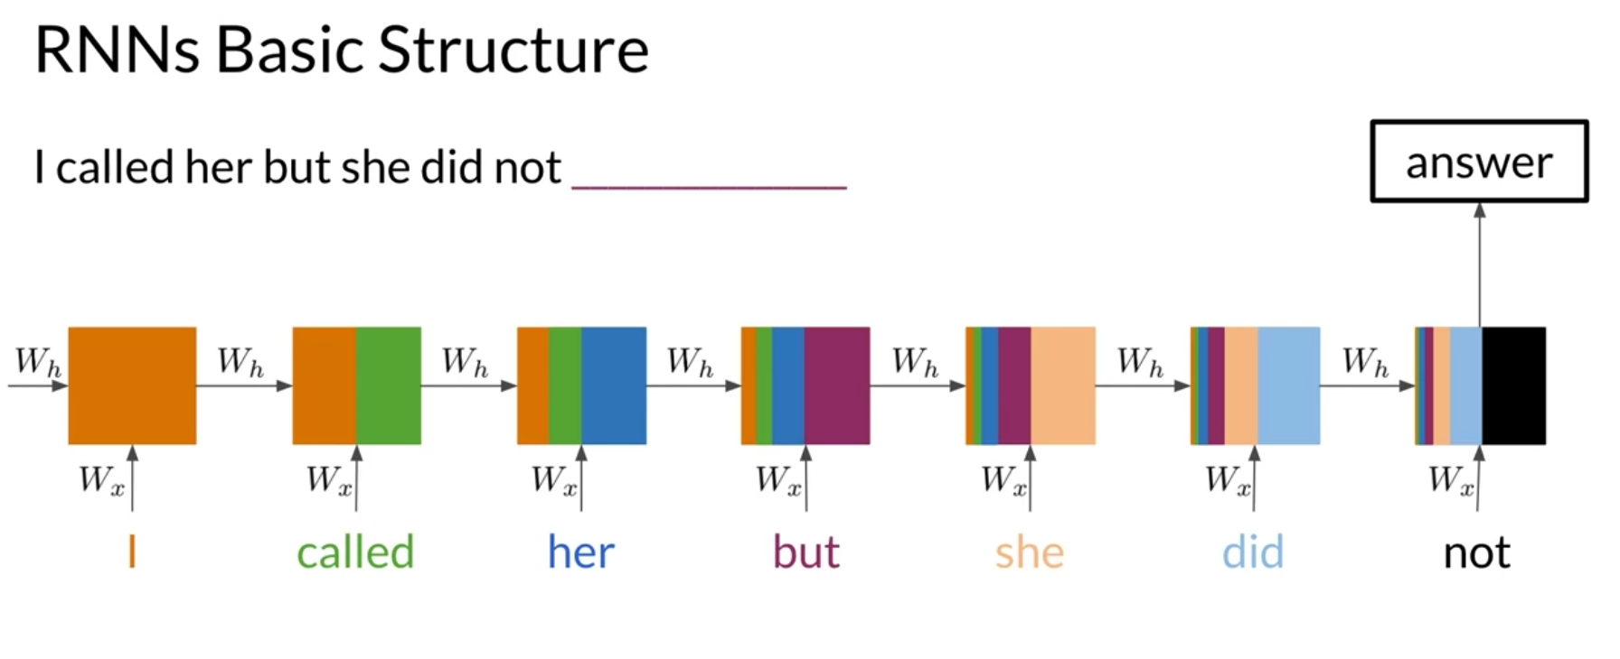

* RNNs can be implemented for a variety of NLP tasks
* Applications include Machine translation and caption generation

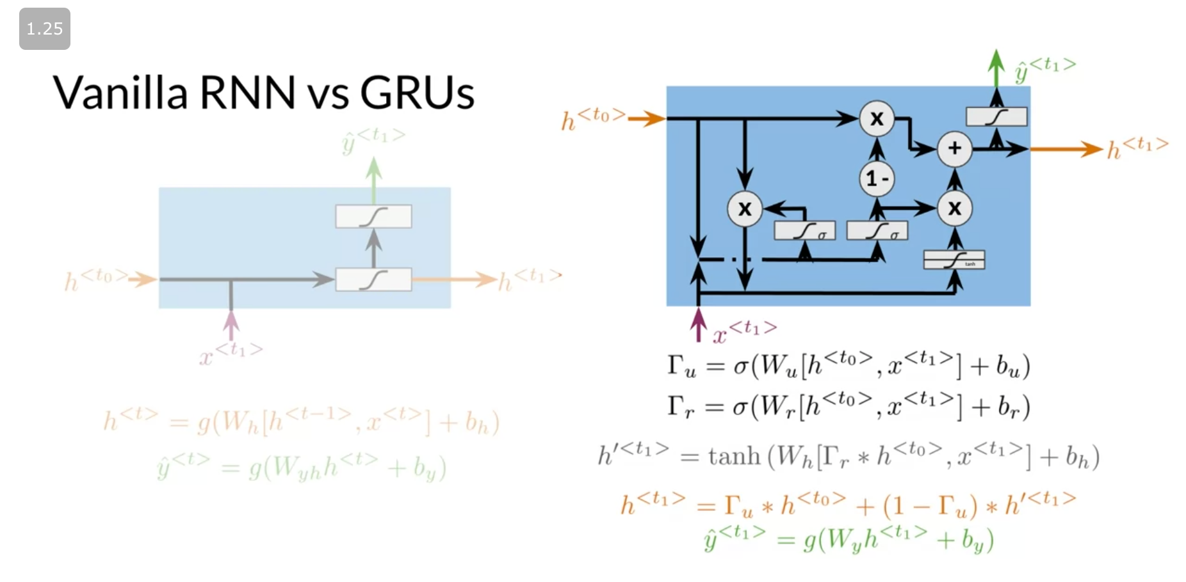

* GRUs "decide" how to update the hidden state
* GRUs help preserve important information

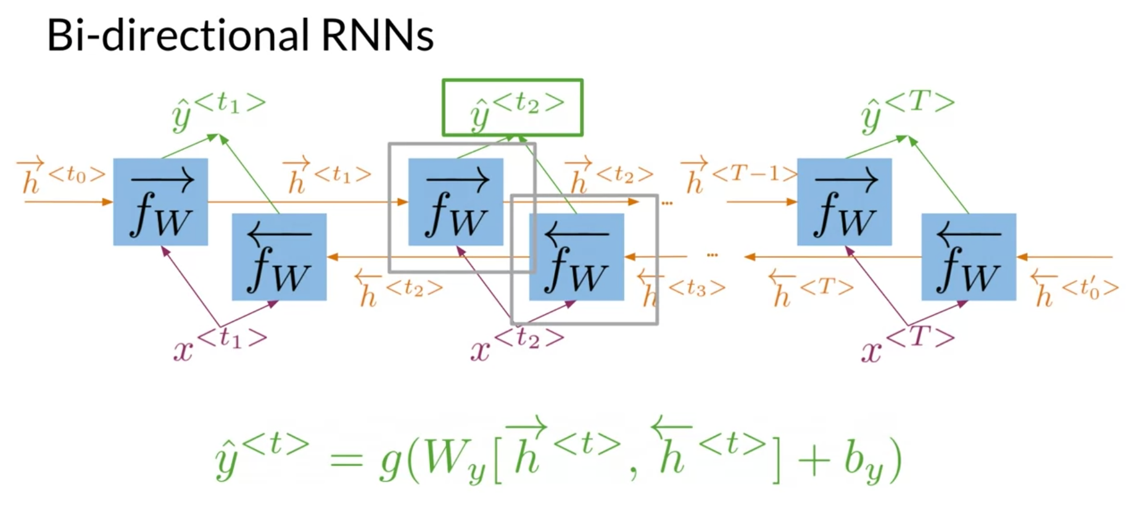

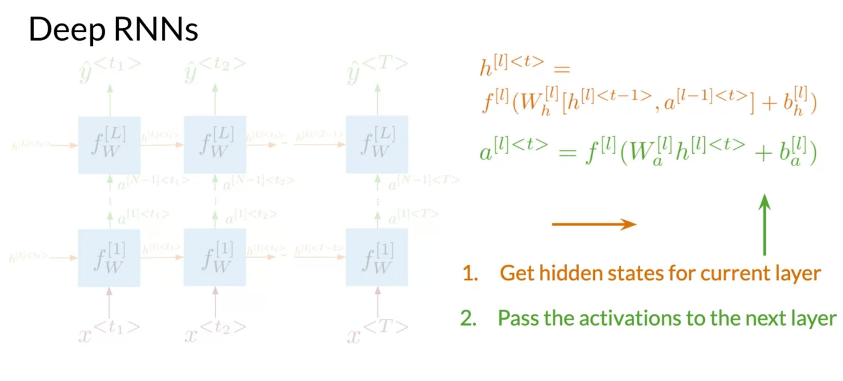

* In bidirectional RNNs, the outputs take information from the past and the future
* Deep RNNs have more than one layer, which helps in complex tasks

## Week 3 - Natural Language Processing with Sequence Models

